**LLD**

An outline for a low-level design documentation for a machine learning project:

1. Introduction

- Project overview

- Objectives and goals

- Scope and limitations

2. System Architecture

- High-level architecture diagram

- Components and their interactions

- Data flow and integration points

3. Data Pipeline

- Data ingestion process and sources

- Data cleansing and preprocessing techniques

- Data transformation and feature engineering methods

- Data storage and retrieval mechanisms

4. Model Development and Training

- Model selection and algorithm choice

- Feature selection and dimensionality reduction techniques

- Model training process and hyperparameter tuning

- Evaluation metrics and validation strategies

5. Model Deployment and Serving

- Deployment environment and infrastructure design

- Containerization and orchestration methods (e.g., Docker, Kubernetes)

- Model serving APIs and endpoints

- Monitoring and logging mechanisms

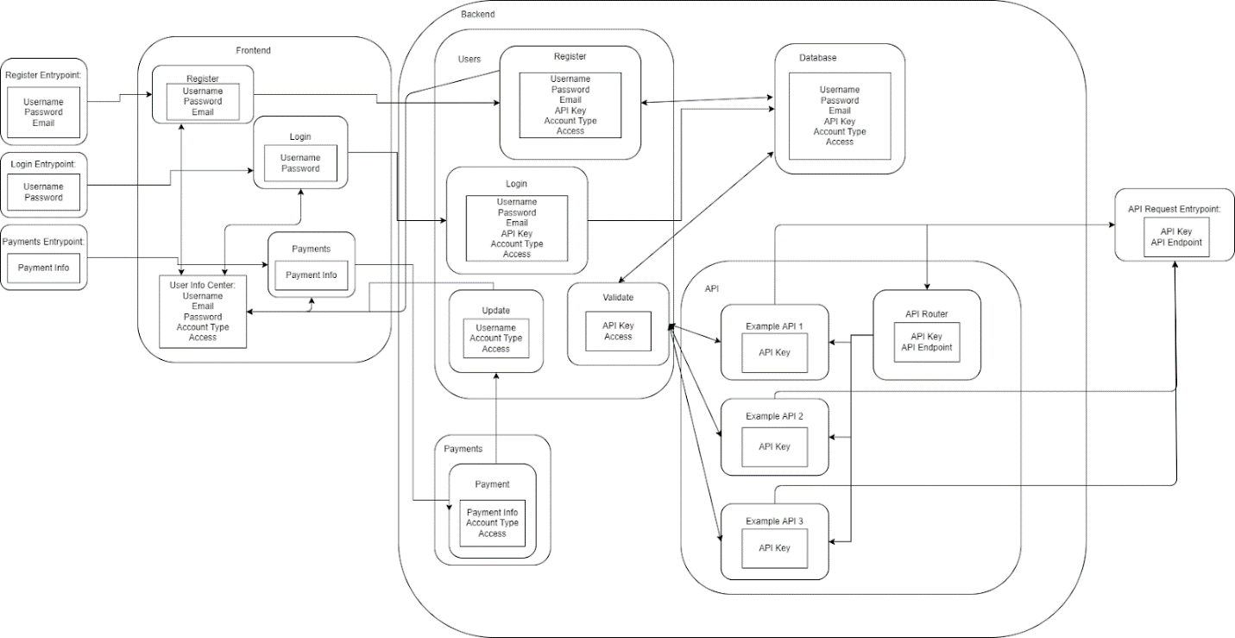

6. Integration and API Design

- Integration with external systems or services

- API design and documentation

- Input validation and error handling

7. Scalability and Performance Considerations

- Load testing and performance optimization techniques

- Scalability strategies for handling increased traffic or data volume

- Caching mechanisms and data retrieval optimizations

8. Security and Privacy

- Data anonymization and privacy compliance measures

- Access controls and authentication mechanisms

- Encryption and secure data transmission

9. Monitoring and Alerting

- Metrics to monitor model performance and health

- Anomaly detection and alerting mechanisms

- Logging and error tracking for troubleshooting

10. Continuous Integration and Deployment (CI/CD)

- Version control and code repository setup

- Continuous integration and automated testing processes

- Continuous deployment pipelines and release management

11. Documentation and Knowledge Sharing

- Documenting code, models, and processes

- Knowledge sharing practices within the team

- User and developer documentation

12. Maintenance and Support

- Bug tracking and issue management

- Regular model retraining and updates

- Incident response and support procedures

**HLD**

An outline for a high-level design documentation for a machine learning project:

1. Introduction

- Project overview

- Objectives and goals

- Stakeholders and users

- Scope and limitations

2. System Architecture

- High-level architecture diagram

- Components and their interactions

- Data flow and integration points

3. Data Collection and Storage

- Data sources and collection methods

- Data storage requirements and architecture

- Data preprocessing and cleansing techniques

- Data quality assessment and assurance

4. Feature Engineering

- Feature selection and extraction techniques

- Feature transformation and normalization

- Handling missing values and outliers

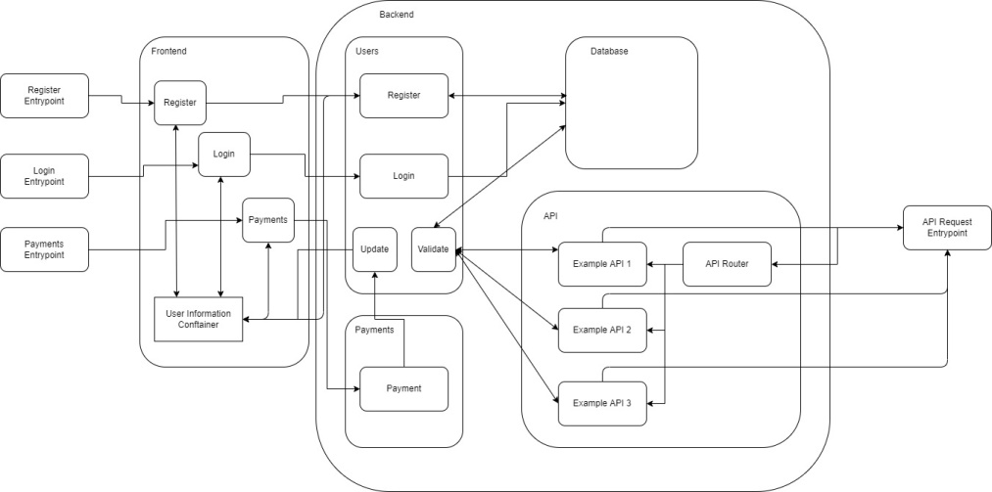

5. Model Development and Training

- Model selection and algorithm choice

- Model architecture and design

- Hyperparameter tuning and optimization

- Training data splitting and validation strategy

6. Model Evaluation and Validation

- Performance metrics and evaluation techniques

- Cross-validation and holdout sets

- Model comparison and selection criteria

- Validation against real-world data

7. Model Deployment and Serving

- Deployment environment and infrastructure design

- Model serving APIs and endpoints

- Containerization and orchestration (e.g., Docker, Kubernetes)

- Scalability and performance considerations

8. Integration and API Design

- Integration with external systems or services

- API design and documentation

- Input validation and error handling

9. Monitoring and Alerting

- Model performance monitoring

- Anomaly detection and alerting mechanisms

- Logging and error tracking for troubleshooting

10. Security and Privacy

- Data anonymization and privacy compliance measures

- Access controls and authentication mechanisms

- Encryption and secure data transmission

11. Maintenance and Support

- Bug tracking and issue management

- Model retraining and updates

- Incident response and support procedures

12. Documentation and Knowledge Sharing

- Documenting code, models, and processes

- User and developer documentation

- Knowledge sharing practices within the team